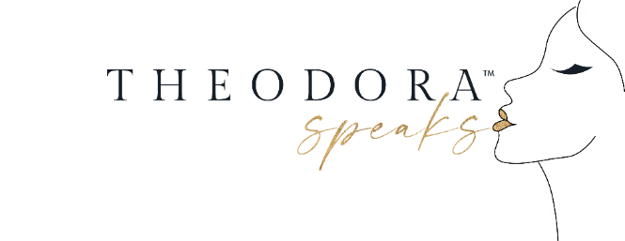

STACIE JONES’ PEANUT BUTTER CHOCOLATE CHIP NICE CREAM
I am obsessed with NICE cream y'all and my latest concoction is probably one of my all time faves. Takes me back to the days that I used to eat Blue Bell ice cream (like after a breakup, when I was craving something sweet, or if I was on a food binge- yikes)! But when I decided to live a plant-based lifestyle (best decision by the way for me) I gave up all that "junk" and never looked back. But between the veggies and the grains, sometimes a girl needs a little comfort food. And Nice cream by the way.. is something that I have on a daily basis. Whether I have a big bowl of it or I mix it in my smoothies (which is amazing- try it you will love it) Nice cream is just as good for your body as it is for your taste buds!
And when you combine peanut butter and chocolate chips with it... how can a girl resist?!
What you need:
4 frozen bananas ( freeze without the skin, chopped)
1/4 cup of almond milk (unsweetened)
2 tbsp. of all natural peanut butter
3 tbsp. of chocolate chips ( I used dairy free ones)
dash of cinnamon
1 tsp. of vanilla extract
Directions:

Blend all ingredients together until you get a soft serve consistency.
Top with banana slices, strawberries, chocolate chips and PB ( really whatever you would like)
Serve and Enjoy Beauties!

